LIFE CYCLE STATE OF WLS 12C

Start Admin and Managed Server using Node Manager

Invoke WLST

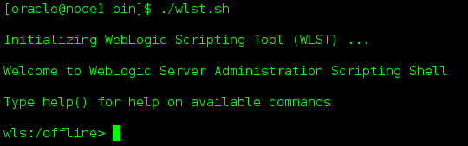

StartNodeManager()



Logs



Connect Node manager

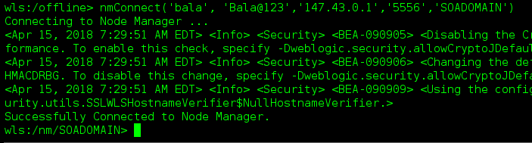

Start Admin Server using nmstart()

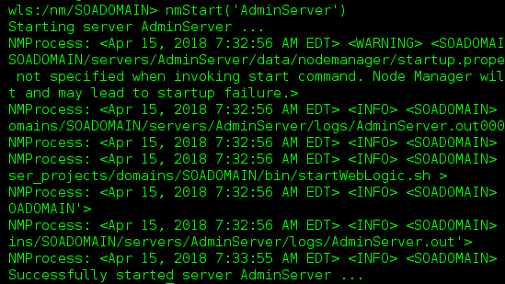

After Starting Admin Server

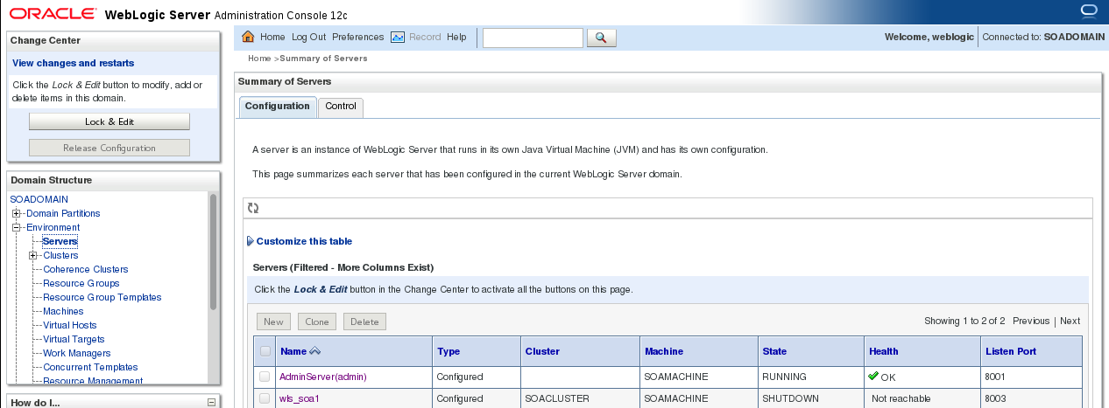

Start Managed Server using nmstart()

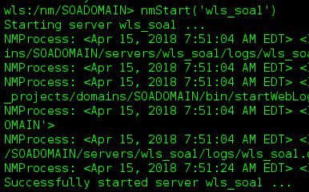

Managed Server Status

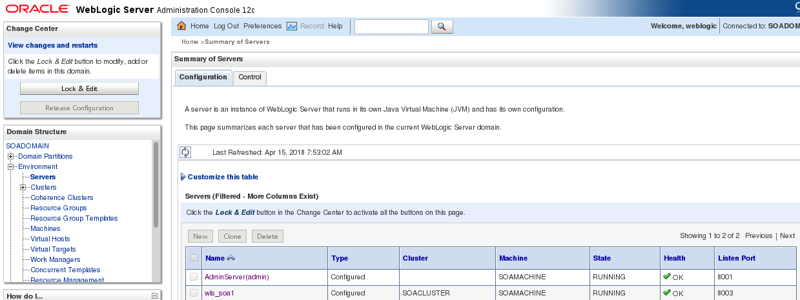

Status of Admin and managed server using nm()

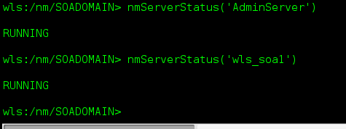

Kill Servers using NM()

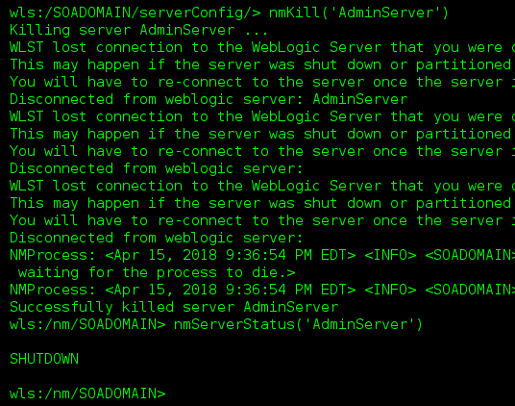

Start Admin and Managed Server without Node Manager

StartNodeManager()



Start Admin server using Serverstart()

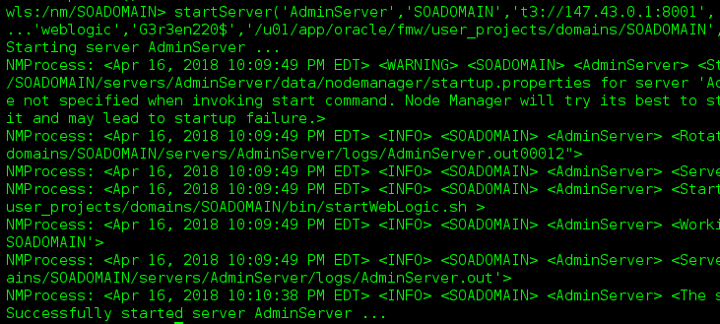

Connect to Admin Server and Start Managed Server

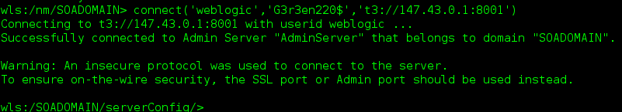

Shutdown Admin Server

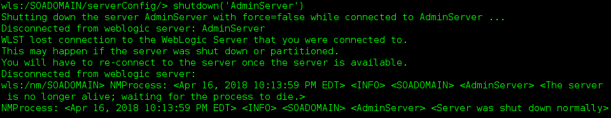

Start Managed Server

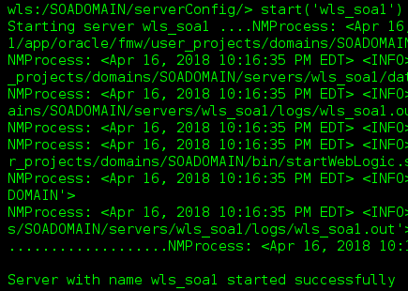

Check the status of server

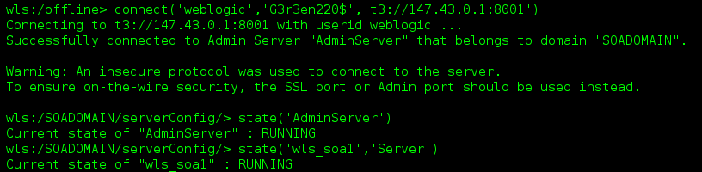

Admin Console status

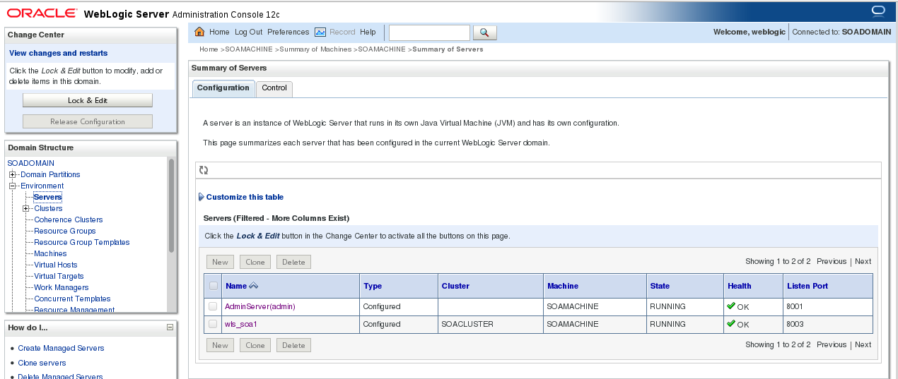

Shutting Down the Managed Server



Points to remember

1.Start admin/managed Server using Script( StartWeblogic.sh)

2.Start admin/managed server using NodeManager (nmStart)

3.Start Admin/Managed server without Node Manager( Start)

Node Manager should be in reachable status to start/stop the servers using WLST.